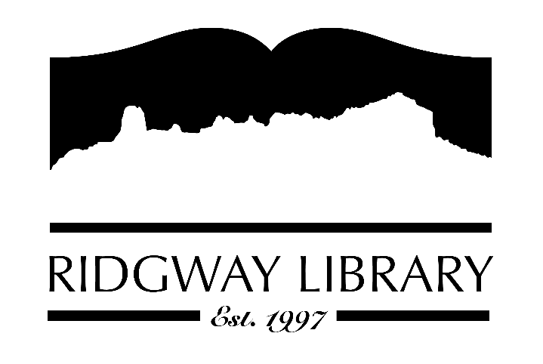

Meeting Minutes
RIDGWAY PUBLIC LIBRARY DISTRICT
BOARD OF TRUSTEES
Regular Meeting
Thursday, January 8, 2026 at 10:30 a.m.

Ridgway Public Library
300 Charles Street

Roll Call: Trustees: Sally Trapp ZOOM), Julie Duff (ZOOM), Jared Coburn, Julie Herrmann, Dee Moore, Heather Patterson
Absent: Alison Etheridge

Approval of Prior Minutes: from December 11, 2025 meeting. Julie Duff clarified the tax credit reference. Motion to approve as amended made by Jared Coburn, seconded by Julie Herrmann.

Next Meeting: Thursday, Thursday, February 12, 2026 at 10:30 p.m.

Public Comments: None

Friends of the Library Update: Jill Hepp was unable to be present. Heather Patterson brought the new tote bags for FOL. Some will be kept and sold at the library for $10. They have been receiving donations from the end of year ask letter and currently have $22,000 available to give to the library.

Highlighted Topic: Adult Bingo began on January 2nd and will run through March 31st

Action and Discussion Items
- Notice of Annual Meeting of the Board, today, was posted. Motion to approve the designated public space for all notices to continue to be the library bulletin board, was made by Sally Trapp, seconded by Jared Coburn.
- Election of officers for 2026: Sally Trapp, President; Jared Coburn, Vice-President; Julie Duff, Treasurer; Dee Moore, Secretary. Motion to approve made by Dee Moore and seconded by Jared Coburn. Amy Baer will send names of officers and terms to BOCC.
- Strategic Plan Update – Sally Trapp gave an update on her contacts with the two strategic planning proposals. After discussion, Anna Szczepanski’s proposal better addresses the help we are looking for. Anna is an employee of CLiC and will be able to give direction and support over the coming months. After reviewing the dates she proposed, the board discussed having her come for our March board meeting. Scope of Plan and another sheet with questions for the board were distributed. We will each fill out these forms and submit them to Amy Baer. We will also look at our Mission and Vision Statements, which Amy will share with trustees in preparation for the February meeting.

Treasurers Report – Julie Duff gave an updated end of year report. Appreciation expressed to Julie for all the work she does on the library’s finances. The year-end budget report was reviewed.

Director’s Report – Amy Baer
- Reviewed the Ouray County holiday schedule which includes 14 paid holidays. Amy will review the holiday schedule for the library to try and coordinate with the county but also what works better for staff and library patrons.
- Statistical Highlights for 2025 include increase in patron count, meeting room usage, adult programming and items pulled from the hold list for our patrons and other libraries. Having the courier come 4 days a week has helped for inter-library usage. Also an increase in tours from both schools.
- Will start PLA report when the site opens later this month and present it to the board when completed.
- The 3rd annual adult bingo began and we have over 50 patrons who have signed up for the bingo. Adult programming is in full swing with two different monthly book clubs and sewing classes twice a month.
- Community Outreach: the library will continue to support Ridgway Film Club meeting space at the Decker Room so films continue to be free to the community. Will continue working with Sherbino also.

Future Agenda Items – Ideas can always be emailed to Sally Trapp or Amy Baer

Adjournment – Motion to adjourn at 11:54 made by Jared Colburn, seconded by Dee Moore.

