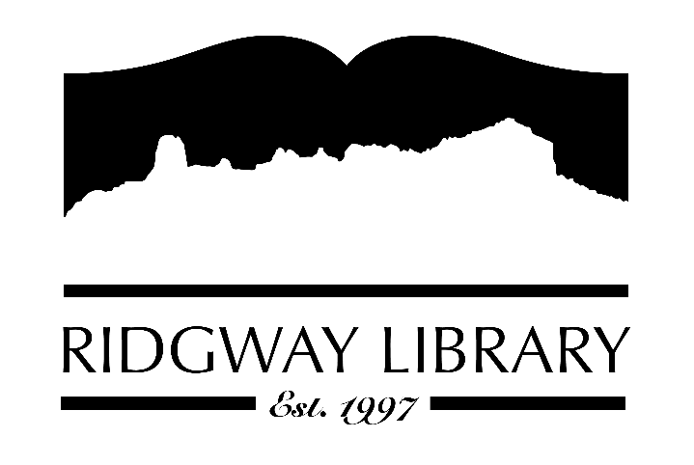

AGENDA
RIDGWAY PUBLIC LIBRARY DISTRICT
BOARD OF TRUSTEES
Regular Meeting
Thursday, March 12, 2026 at 8:30 a.m.

Ridgway Public Library
300 Charles Street

Roll Call: Trustees: Julie Duff, Alison Etheridge, Jared Coburn, Julie Herrmann, Dee Moore, Heather Patterson, Sally Trapp, Library Director: Amy Baer

Approval of Prior Minutes: from February 12, 2026 meeting

Next Meeting: Thursday, April 9th at 10:30 a.m.

Public Comments:

Friends of the Library Update: plan to pass funds to library, possibly today during our meeting break

Highlighted Topic: Lots of continued participation from adults for Winter Bingo Challenge over 100 participants have signed up. Tuesday March 31st will be final day.

Action and Discussion Items:
- Strategic Plan Workshop with CliC consultant – all trustees
- Sign off on 2025 Audit Exemption during our meeting break – Amy

Treasurers Report - Julie Duff
- Budget update during workshop as needed

Director’s Report - Amy Baer
- 2025 PLAR is submitted to the state
- Many computers in the library have been updated
- Attended San Juan Regional COAD via zoom (Community Organizations Active in Disaster) next meeting April 27th

Future Agenda Items

Sally to discuss CAL president’s zoom forum outcomes and goals

Adjournment
The Board reserves the right to add or delete items of business and to change the order of business as needed. The Board welcomes public participation in the meetings. If specific accommodations are needed, please contact the Director, Amy Baer, (970)626-5252 or email abaer@ridgwaycolibrary.org at least 24 hours in advance of the meeting.

