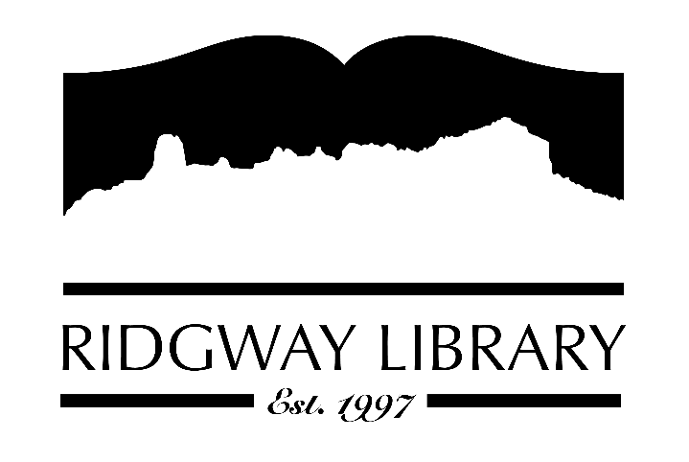

Meeting Minutes
RIDGWAY PUBLIC LIBRARY DISTRICT
BOARD OF TRUSTEES
Regular Meeting
Thursday, February 13, 2025 at 1:00 p.m.

Ridgway Public Library
300 Charles Street

Roll Call: Trustees: Julie Duff, Alison Etheridge (Zoom), Jared Coburn, Julie Herrmann (Zoom), Dee Moore, Heather Patterson, Sally Trapp, Library Director: Amy Baer

Approval of Prior Minutes: from January 8, 2025 meeting, Heather Patterson made a motion to approve, seconded by Julie Duff.

Next Meeting: Thursday, March 13, 2025, 10:30 a.m. Future meetings will be set at the March meeting.

Public Comments: Jared Coburn announced the chess meetings Monday evenings at Steps. All interested chess players are welcome to attend.

Friends of the Library Update: Jill Hepp was unable to be present. Amy reported Friends have approximately $30,000 they will be contributing to the Library.

Highlighted Topic: Author Jon Waterman will be at the Sherbino on Wednesday February 26th at 6:30. Tickets $10 in advance. Books will be available for purchase.

Action and Discussion Items:
- Anna Szcepenski from CLiC, Colorado Library Consortium, held a Board development session. It was a very informative interactive session appreciated by all the Board trustees. Anna is willing to come back and work with us on a strategic plan or other educational sessions.
- Amy presented the 2024 audit exemption for state audit to be signed by all trustees.
- Before the Board meeting Sally Trapp and Dee Moore met to review the CAL Awards application. A subcommittee of Dee Moore, Jared Cobern, Julie Hermann and Sally Trapp will meet before the March meeting at which time the committee will present their recommendations.
- A subcommittee for evaluation form and compensation review for Amy will be appointed at the next meeting.

Treasurers Report - Julie Duff
- Julie highlighted our refund to the county. We ended the year with a healthy surplus.

Director’s Report – Amy Baer
- Statistic Highlights for January – The Library had a busy January with lots of overall use and participation. Working on the PLAR report which is 75% completed.
- Betsy and Caitlin both participated in CLiC’s virtual winter workshop sessions.
- Adult programming is going well. Winter Bingo has 78 sign-ups. Tech Tuesdays every 2nd and 4th Tuesdays going well. The first sewing class was full and the next class is also full. Conversational Spanish is well attended on Thursdays.
- The directors meeting will be in Granby in May.

Future Agenda Items – Report from the attorney who reviewed our policies and other subcommittees we may wish to set up.

Adjournment – Motion to adjourn, 3:34 p.m. by Jared Coburn, seconded by Sally Trapp.

