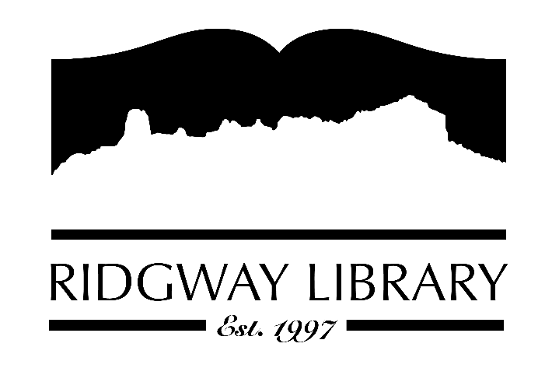

Meeting Minutes
RIDGWAY PUBLIC LIBRARY DISTRICT
BOARD OF TRUSTEES
Regular Meeting
Thursday, May 28, 2026 at 9:00 a.m.

Ridgway Public Library
300 Charles Street

Roll Call: Trustees: Sally Trapp, Julie Duff, Jared Coburn, Alison Etheridge, Dee Moore, Heather Patterson, Library Director Amy Baer; Anna Szczepanski, CLiC Consultant

Absent: Julie Herrmann

Approval of Prior Minutes: from April 16, 2026 meeting. Motion to approve made by Jared Coburn, seconded by Julie Duff.

Next Meeting: Thursday, June 11th at 9:30 a.m.

Public Comments: Lia Salvatierra, Ouray County Plaindealer, present to observe and write an article for newspaper on the strategic planning we are doing.

Friends of the Library Update: Family Fun Fest and book sale May 30th from 10:00-1:00. FORL shirts received and available for $15.

Highlighted Topic: Summer Reading Challenges begin June 1st and Summer programs begin June 4th.

Action and Discussion Items
- Strategic Plan Workshop with CLiC consultant, Anna Szczepanski.

Treasurers Report – Julie Duff reviewed April finances. We will receive balance of property taxes in July.

Director’s Report – Amy Baer
- Statistics: reviewed book circulation, Kanopy use and volunteer hours. More than 100 have attended craft classes.

Future Agenda Items – Sally to discuss CAL president’s zoom forum outcomes/goals and review library employee compensation.

Adjournment – Motion to adjourn at 12:12 by Alison Etheridge, seconded Jared Coburn.

