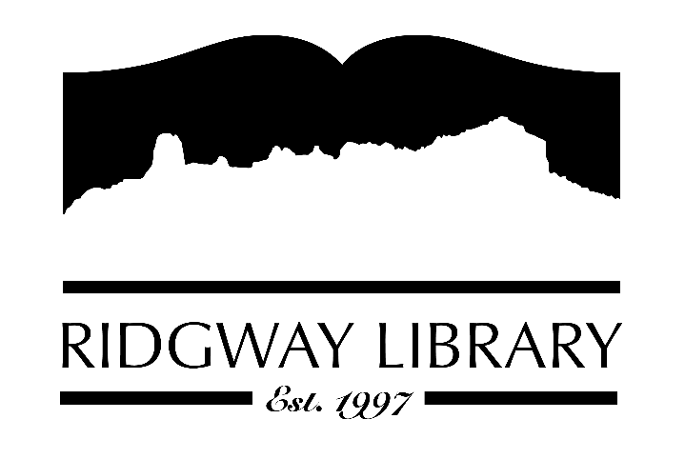

AGENDA
RIDGWAY PUBLIC LIBRARY DISTRICT
BOARD OF TRUSTEES
Regular Meeting
Thursday, September 10, 2026 at 10:00 a.m.

Ridgway Public Library
300 Charles Street

Zoom option:
https://us06web.zoom.us/j/83007241153?pwd=G4Q4tQFfSU6coRbaQOztqB1AMfRPPb.1
Passcode:
766797
Roll Call: Trustees: Julie Duff, Alison Etheridge, Jared Coburn, Julie Herrmann, Dee Moore, Heather Patterson, Sally Trapp, Library Director: Amy Baer

Approval of Prior Minutes: from June 11, 2026 meeting

Next Meeting: Thursday, October 8, 2026 at 10:00 a.m.

Public Comments:
.
Friends of the Library Update: Annual August Booksale update

Highlighted Topic: Art Show Saturday, September 12th from 4:00-7:00pm

Action and Discussion Items:
- Present 2026 Budget – Julie Duff
- Public hearing on Thursday, October 10th
- Strategic Plan Update
- Compensation sub-committee report – Dee
- Review documentation from CliC consultant – all trustees
2. Executive Session 24-6-402(4) (f) C.R.S. personnel matters regarding annual evaluation of the executive director and other compensation results from sub-committee – all trustees

Treasurers Report - Julie Duff
- Budget update – presented during action items

Director’s Report - Amy Baer
- Summer Overview
- Maintenance Update
- Outreach Update

Future Agenda Items

Sally to discuss CAL president’s zoom forum outcomes and goals

Adjournment
The Board reserves the right to add or delete items of business and to change the order of business as needed. The Board welcomes public participation in the meetings. If specific accommodations are needed, please contact the Director, Amy Baer, (970)626-5252 or email abaer@ridgwaycolibrary.org at least 24 hours in advance of the meeting.

