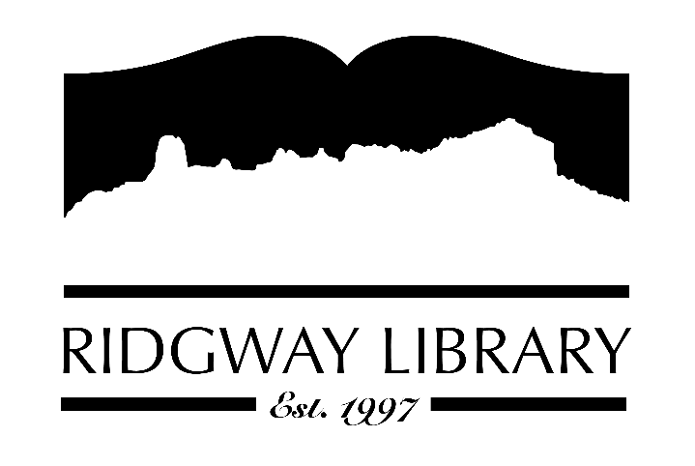

Meeting Minutes
RIDGWAY PUBLIC LIBRARY DISTRICT
BOARD OF TRUSTEES
Regular Meeting
Thursday, April 10, 2025 at 10:30 a.m.

Ridgway Public Library
300 Charles Street

Roll Call: Trustees: Julie Duff, Alison Etheridge, Jared Coburn, Julie Hermann, Dee Moore, Heather Patterson, Sally Trapp (ZOOM), Library Director: Amy Baer

Approval of Prior Minutes: from March 14, 2025 meeting, Jared Coburn made motion to approve, seconded by Julie Hermann

Next Meeting: Thursday, June 5, 2025, 1:30 p.m.

Public Comments: None

Friends of the Library Update: Jill Hepp was unable to be present. Julie Hermann and Amy Baer attended their March 26th meeting. One of their goals is to tie into library events more. FORL will host Family Fun Fest on Saturday, May 31st. Looking at replacing PayPal for donations with a non-profit such as Donor Bridge. Amy is working closely with them to consolidate website information. Friends gave a $32,000 donation to the library. A Thank You card will be signed by all Trustees and sent to Friends.

Highlighted Topic: Upcoming Bee Class on Saturday, April 26, 10:00 a.m. presented by Terra Malstrom. Bee pollinator and wildflower seed packets will be distributed during the class.

Action and Discussion Items
- Material Selection Policy – After reviewing policies from many other libraries, Allison Etheridge and Julie Hermann presented their recommended changes for our policy and a new form to be included Material Review Request. After extensive review and some changes, Jared Coburn recommended we adopt the Material Selection Policy and Form, seconded by Julie Hermann. Amy will send out the policy with all the changes.
- Free for All – The Public Library documentary produced 5 years ago has been picked up by PBS and is available to be shown through Indie Lens. Amy contacted The Sherbino and they are available to host the event on May 13th at 6:30 pm. This will be a free event for our community. After the presentation, there will be a panel for discussion and answering questions. Amy, Jill from FORL and Jared, a board trustee are the scheduled panel. Allison offered to serve on panel also if needed.
- CAL Awards update – Dee thanked everyone for gathering information and writing letters for the nominees. In addition to the nomination letter, a support letter is also required. Each trustee gathering info will send the letters and photos to Amy. Dee and Amy will coordinate the information to be submitted by May 15, 2025.
- 2025 Board Goals – Sally reviewed Board goals and Amy emailed out on March 17th. Julie Duff and Jared volunteered to work on By-Laws; Dee and Allison will work on Library Director evaluation.

Treasurers Report - Julie Duff
- Julie reported the budget is on target. Received $5,000 grant from Dave and Mary Wood in March as well as $32,000 from Friends of the Library.

Director’s Report – Amy Baer
- Statistic Highlights for March – another busy month at the library. PLAR report is completed but still waiting on statistic sheet from lrs.org
- Programs – 29 attendees for Garden Tips Class. Bee Class on April 26. Kids Chess Club on Mondays at 3:45-4:30, Jared Coburn will continue hosting until the end of the school year. Adult Bingo is finished – 83 signed up, 12 completed bingo sheets and 34 turned in at least 1 Bingo. Getting ready for summer reading programs including a new writing club hosted by Caitlin on Mondays.
- Maintenance – Climb Tree Service will finish work this month. The building permit application was picked up by the roofer. Tentative date will be in May. Quote was received to draft documents for sidewalk repair. A fence enclosure quote was received for repairing the garbage enclosure, which was higher than expected so will come up with another plan. A wall mount was installed to better regulate heat in the entryway. EXIT signs were LED but the library needed other LED bulbs replaced which were ordered and installed.
- Staff Conferences – Betsy and Caitlan attended Youth Conference, hosted by Colorado State Library in Bayfield, March 26th. Caitliln wrote a thank you letter and report on a conference she attended last month. Amy will send this to Trustees.

Future Agenda Items – Review Goals and establish more sub-committees as needed.

Adjournment – Motion to adjourn, 12:44 p.m. by Sally Trapp, seconded by Jared Coburn

