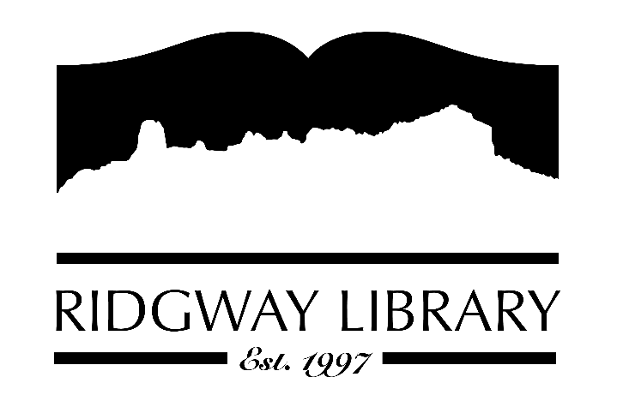

Meeting Minutes
RIDGWAY PUBLIC LIBRARY DISTRICT
BOARD OF TRUSTEES
Regular Meeting
Thursday, April 26, 2026 at 10:00 a.m.

Ridgway Public Library
300 Charles Street

Roll Call: Trustees: Sally Trapp, Julie Duff, Alison Etheridge (Zoom), Jared Coburn, Julie Herrmann (Zoom), Dee Moore, Heather Patterson, Library Director Amy Baer; Anna Szczepanski, CLiC Consultant

Approval of Prior Minutes: from March 12, 2026 meeting. Motion to approve made by Jared Coburn, seconded by Heather Patterson.

Next Meeting: Thursday, May 21st at 10:30 a.m. with Anna Szczepanski

Public Comments: None

Friends of the Library Update: Next meeting is April 21st at 3:50 to discuss Annual Fun Fest to be held Saturday, May 30th. Volunteer opportunities will be available. Heather Patterson brought samples for t-shirts. Minimum per style is 60 pieces. Amy Baer will take the samples to the April 21st meeting.

Highlighted Topic: Upcoming Garden Composting Class by Chris Lance on April 25th at 10:00 a.m.

Action and Discussion Items
- Strategic Plan Workshop with CLiC consultant, Anna Szczepanski.

Treasurers Report – Julie Duff reviewed March financials. Budgeted 5% increase for employee health insurance which came in at 9.5%

Director’s Report – Amy Baer
- Statistics: We are off to a good start and keeping good stats to reflect our activity. Still would like to see numbers increase with Cloud Library. See PLAR Report to compare last two years.
- CDE Grant Update: Newest purchase of 3 mini Yoto players for check out and 1 full size for the listening center in the children’s area. Mini Yoto players and story cards will be at the front desk for check out.
- Staff Workshop: Betsy is attending a Young Adult focused workshop in Denver on Saturday.
- Technology Update: New copier/scanner arriving Friday, 17th. Decided to keep Apple/MAC computers since they are still working fine.
- Spring Outdoor Maintenance: Communication has been made for clean-up which will take place in April. Some tree maintenance began this week. Lawn care will begin when town water is turned on.
- Dark Sky Collaboration: The library collaborated with Top of the Pines, Ridgway Elementary School and Ridgway Ouray Community Council (ROCC) to bring Jessa Young to educate students about our night sky and nocturnal animals. New dark sky books were purchased on behalf of a donation made by ROCC. Library has a dark sky book display for both adults and children during month of April. I went to BOCC this week to help support the proclamation to have Ouray County adopt April and May as dark sky months to support the nationwide dark sky initiative.

Future Agenda Items – Sally to discuss CAL president’s zoom forum outcomes and goals.

Adjournment – Motion to adjourn at 11:55 a.m. made by Jared Coburn, seconded by Julie Duff.

