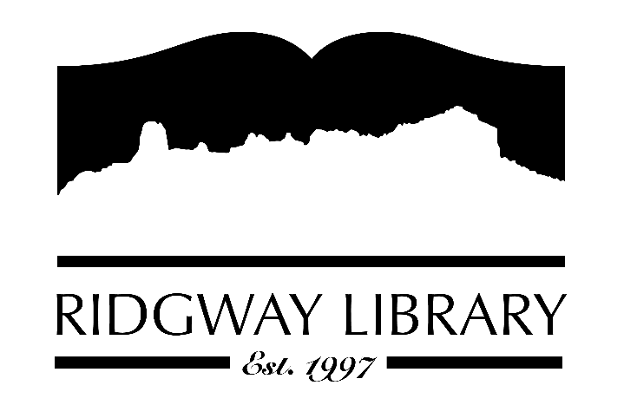

PUBLIC NOTICE
RIDGWAY PUBLIC LIBRARY
300 CHARLES STREET
RIDGWAY, CO 81432

Minutes from the Special Board Meeting/Work Session
Thursday, April 23, 2026 at 6:00 p.m.

Trustee Sally Trapp called the meeting to order at 6:38 p.m.

No action was taken during the work session; working groups presented their information on the data gathered for the strategic plan.

Motion to Adjourn: 8:02, Made by Julie Herrmann, Seconded by Heather Patterson; all approved.

